Top Secret SCI
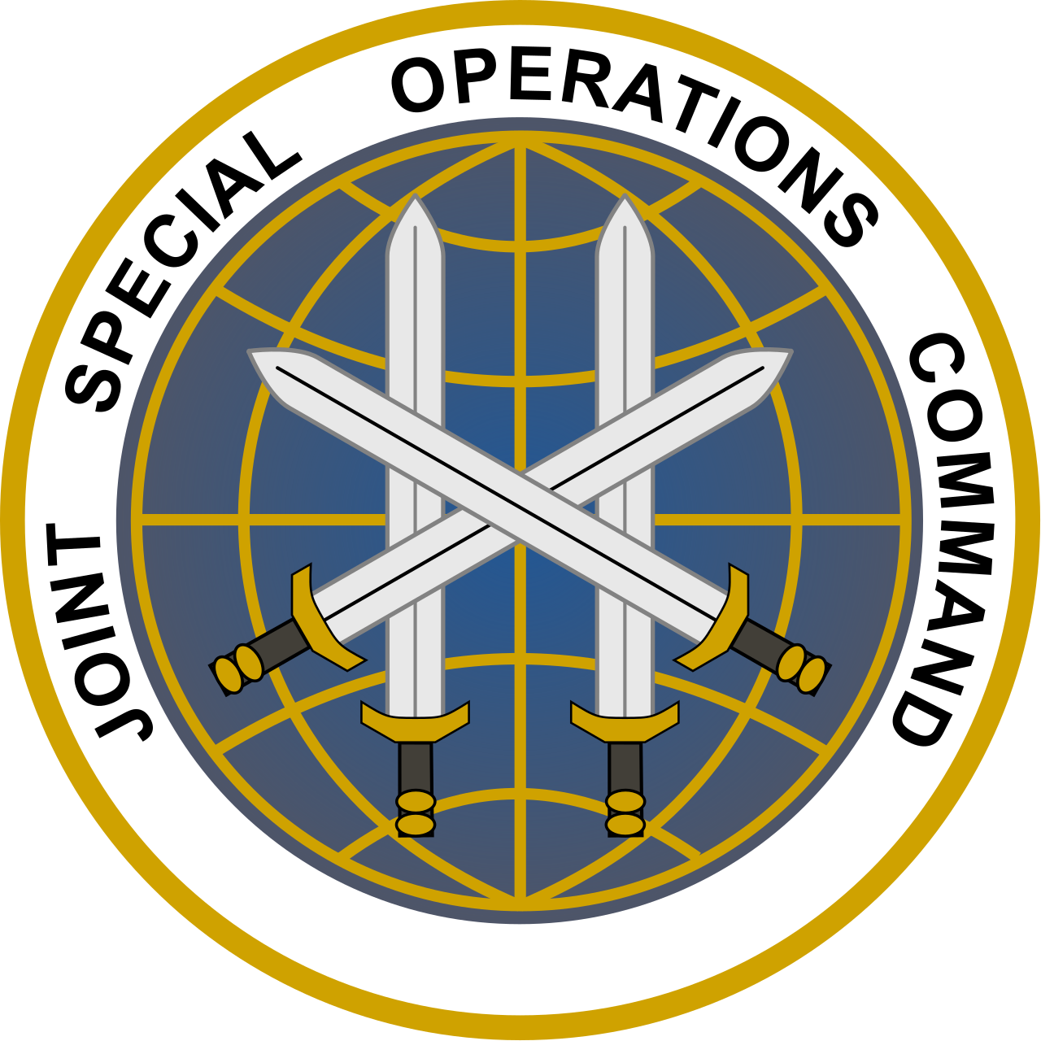
050622023
From: Joint Special Operations Command
To: Commander NSWDG Silver Squadron
Re: Operation Voodoo Child

Situation:
Eight weeks ago three JSOC personnel arrived at Luanda, Angola and met up with IDAP representatives. The next day they boarded an IDAP helicopter to be flown into Matala; in the province of Huíla, Angola. This helicopter was shot down approximately 20Km northwest of Matala. These were members of an advanced deployment JSOC intelligence gathering team that were posing as members of the demining operations being run by the IDAP relief agency. Their mission was to establish the forward communications and support operation no later than 7 days prior to the arrival of the remaining members of their team. These personnel were to run local control of all SIGINT and drone flights for the follow-on special reconnaissance team in order to provide a wide spectrum of overhead imagery, satellite communication links and extraction and medical support. The advanced team's primary mission was to begin a ELINT/COMINT search in the region for what is believed to be the new location of the Ansar Dine Islamic group; while posing as demining experts working for IDAP.

The helicopter was shot down approximately 20km northwest of Matala. IDAP has forwarded recorded video and still images of one pilot that is seriously wounded and two other bodies that we are unable to identify; along with three other individuals that we believe are our personnel. The images are not clear enough to get facial recognition to work properly. We do believe that there are a total of four living hostages and two deceased for recovery. IDAP has also forwarded recorded sat phone communications from at least one member of their crew that phoned in shortly after they lost radio communications with the helicopter as it was flying into Matala. During the call the crew member confirmed they were shot down and one crew member was dead as a result of injuries from the crash. The others apparently did not have significant injuries but much of that may have changed in the last few weeks.

Carrier Strike Group – 10 (CSG-10) was enroute to the Mediterraenan when it was diverted to the west coast of Africa to support this mission. The strike group is centered on the USS Eisenhower and has a full carrier air wing and helo squadron that has performed work with all parts of NSWDG in the recent past in training operations. These air crews are willing and able to support a rescue and recovery operation as soon as it can be planned and tasked.

Angolan forces have been unable to move into the region where the helicopter is believed to have crashed due to rebel control of the area. The Angolan forces are outnumbered and outgunned as the rebel militia that controls the area is reported in possession of several older but very servicable Soviet era medium and light armored vehicles that were in use during the wars here within the last 50 years.

Within the last 24 hours a Russian Navy Task Force centered on the Battlecruiser Pyotr Velikiy has arrived off the western coast of Africa and has positioned itself between CSG-10 and the Angolan coast. Within the last 12 hours we have tracked at least 10 helicopter flights from the 2 Ropucha-class ships and the single Ivan Gren landing ships in the task force to the airport northeast of the Matala region. The helicopters used appear to be heavy lift capable and have been seen sling loading GAZ “Tigr” vehicles from the ships. When asked about the sudden appearance of the Russian navy off their coast the Angolan officials mentioned that the arrival of Russian troops in their country was expected for a joint training exercise but the exercise was not scheduled for another 2 months. We have reason to believe the Russian government may know the true identity of the hostages and are moving to recover them and move them to Russia before we can act.

Two weeks after the crash of the helo our forward reconnaissance team was moved in-country to see if they could location the group that was holding the remaining members of the crashed helo. Together with a small special reconnaissance detachment of French SOF from Commando Trépel they believe they have located the area where a message originated about 1 hour ago. At that time IDAP received a message with the details of where and how to make a ransom payment; along with information about when and where they can expect to find their personnel after the payment has verified. They were told to have payment ready within 72 hours and once details are sent with the payment information they will have 4 hours to make the payment or all hostages will be killed publicly.

Our special reconnaissance team believes they have the location of the hostage takers. Due to the nature of the latest communication from the hostage takers and the arrival of the Russians; we are pushing our timeline to locate and extract our hostages forward by no less than 48 hours. We will begin air operations to move Silver Squadron into the region immediately. This will be done in coordination with the Angolan Air Force as part of what we are calling a pre-planned air exercise in the hopes of being able to obscure the flights for the HALO drop; as well as palletized paradrops of ground transport into the region. We will drop 3 different detachments into the area from CV-22's over the next 8 hours. The first detachment departs at sundown in 90 minutes.

Objectives:
- Dagger - Conduct close target reconnaissance of suspected areas to locate and establish hostage location(s).
- Raider, Noble & Crimson - HALO insertion and paradrop of ground transport equipment to DZ’s within the region.
- Dagger, Raider, Noble & Crimson - Will conduct the raid of HVI location and secure hostages.
- Warlock - Extraction of all ground elements back to the US Navy carrier off the coast of Angola.

***Please note that plans, mission orders, and anything else pertaining to our operation could change at a moment's notice. Please make sure you are paying attention and echoing communications to all team members.***

Weather
- Expect dry and dusty conditions within the region; with air temperatures in the low 70’s at night and upper 90’s during the day. There will be a low overcast with a partially visible moon on the during the HALO insertion and travel to hide sites within the target area.

Enemy Forces
- Ansar Dine Islamic militia
- Possible non-aligned African militia

Unknown Forces
- Russian Special Operations Forces
- Russian Naval Aircraft

Friendly Forces
- Havoc - Angolan Armed Forces
- Dagger - Joint NSWDG and FORFUSCO (French SOF) special reconnaissance team
- Raider, Noble & Crimson - DEVGRU Silver Squadron
- Warlock - VRM-40/160th SOAR/56th Rescue Sq.

Mission
Who: DEVGRU Silver Squadron
What: Locate and assault target and extraction of hostages
When: TBD
Where: Southwest Angola
Why: To return hostages to the US and to eliminate Ansar Dine as a force in central Africa.

Intel Liaisons Comments
- Review intelligence briefs at the end of the document and all relevant links to further information on friendly and potential enemy combatants in the region.

AIR WING ASSET REQUESTS
- 3x CV-22B/MV-22
- 1x MH-47G
- 2x F/A-18 E/F
- 1x F/A-18G
- 1x HH-60G

Service & Support
Uniforms and equipment - Uniform of choice for operators as long as it falls within color scheme for local terrain and foliage.
Arms & Ammo - As stated by team leaders and roles.
Transportation - VRM-40: Will provide all transportation for HALO drop of troops and paradrop transport of 4x DAGOR A1’s for mobility of assault teams via CMV-22B’s.
Close Air Support - VFA-105: will handle all close air support during ground operations; as well as diversion/masking operations during infiltration movement of assault teams.
Medical Evacuation - 56th Rescue Squadron: Using HH-60G helicopters will cover all medical emergencies before exfil of assault teams and hostages.
Extraction: 160th SOAR: will handle all exfil operations of teams and hostages from the target area.
EPOW’s - Any captured Ansar Dine or Russian troops are to be left in a location to be given to the Angolan Armed Forces after the completion of the hostage recovery.
Other - Leadership will hand down any additional assignments immediately ahead of operation start.

Command and Signal
Signal
Long Range Channels
- Havoc Command - 50
- Dagger Drone Ops - 62
- Warlock Air Ops - 63
Short Range Team Channels
- Dagger ISA/Close Recon - 100
- Raider Assault - 110
- Noble Assault - 120
- Crimson Assault - 130
- Warlock Aviation - 140

Intelligence:
Team leaders should reference the “Please Review” section for relevant information before the operation starts; any new information will be provided as it is developed once the operation starts.

Please Review:
HVI/POI Ansar Dine Leadership Bulletin Board
Operation Voodoo Child Friend/Foe Intelligence Report

